Statistics & Probability | 4th Quarter
MPT 1: Scatter Plots
April 6 2021

Instructions:
- Identify the independent variable and dependent variable.
- Construct a scatter plot.
- Determine the direction of the straight line that the data points seem to follow.
- Determine the strength of correlation between the two variables.

- The table shows the number of hours spent by 8 students in using the Internet and their scores on a Mathematics test.
Student | Hours Using the Internet | Scores
1 | 1 | 30
2 | 2 | 25
3 | 3 | 20
4 | 2 | 30
5 | 0.5 | 26
6 | 2.5 | 15
7 | 2 | 32
8 | 3 | 15
Independent Variable: Hours Using The Internet
Dependent Variable: Scores
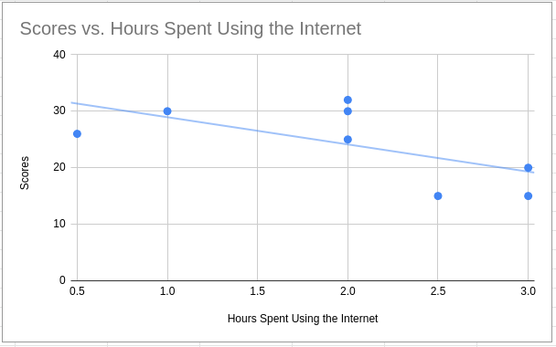
Moderate Negative Correlation.
- The table shows the number of hours spent in the mall by 12 persons and the amount of money they spent when they go to the mall.
Person | Hours in the Mall | Amount of Money Spent (SAR)
1 | 8 | 600
2 | 10 | 1000
3 | 9 | 500
4 | 3 | 600
5 | 1 | 200
6 | 7 | 900
7 | 6 | 500
8 | 4 | 800
9 | 5 | 500
10 | 2 | 100
11 | 3 | 400
12 | 4 | 600
Independent Variable: Hours in the Mall
Dependent Variable: Amount of Money Spent
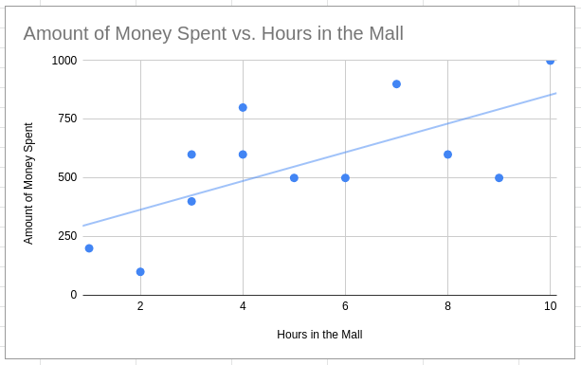
Weak/Moderate Positive Correlation.
- Shown in the table below are the number of hours spent by 8 students in studying and their scores in a Mathematics test.
Student | Hours Spent Studying | Scores
1 | 4 | 40
2 | 2 | 25
3 | 1 | 20
4 | 3 | 30
5 | 2 | 20
6 | 3 | 25
7 | 1 | 20
8 | 4 | 35
Independent Variable: Hours Spent Studying
Dependent Variable: Scores
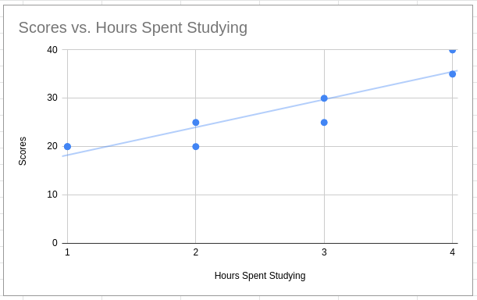
Strong Positive Correlation.
- The table shows the number of cups of coffee that 8 persons had in one week and their systolic blood pressure numbers after one week.
Person | Number of Cups of Coffee | Systolic Blood Pressure Number
1 | 5 | 110
2 | 4 | 115
3 | 7 | 100
4 | 10 | 120
5 | 14 | 130
6 | 6 | 110
7 | 12 | 110
8 | 16 | 120
Independent Variable: Number of Cups of Coffee
Dependent Variable: Systolic Blood Pressure Number
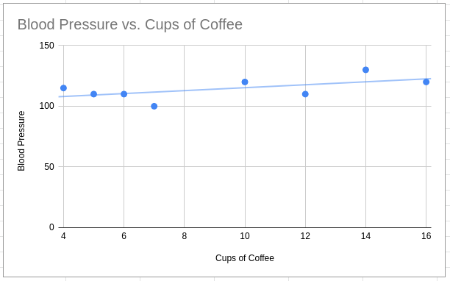
Strong Positive Correlation.
- Rosalinda de Castro has a private resort. She decided to record the temperature in one week and the number of guests who came to her resort for that week. The data are shown below.
Day | Temperature in C | Number of Guests
1 | 27 | 600
2 | 28 | 1000
3 | 29 | 1500
4 | 31 | 2500
5 | 26 | 900
6 | 30 | 1000
7 | 31 | 2600
Independent Variable: Temperature
Dependent Variable: Number of Guests
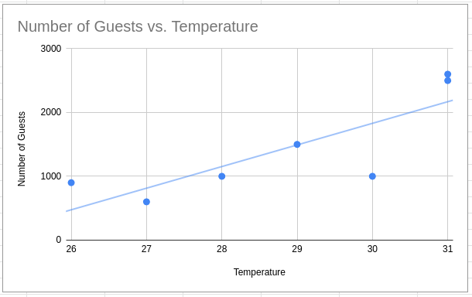
Moderate Positive Correlation.

